**A Major Project**

**On**

VAULT SECURITY SYSTEM

SUBMITTED IN PARTIAL FULFILLMENT OF THE REQUIREMENT FOR THE AWARD OF THE DEGREE OF

**Bachelors of Technology**

(Electronics & Communication Engineering)



JAN-JUN 2023

**SUBMITTED BY:** VAULT SECURITY SYSTEM

AJAYPAL SINGH MATHARU 1905189 **UNDER THE GUIDENCE OF:**

ISHAVJOT SINGH 1905220 PROF. SIMRANJIT KAUR

TEJVEER SINGH 1905274

DEPARTMENT OF ELECTRONICS & COMMUNICATION ENGINEERING

GURU NANAK DEV ENGINEERING COLLEGE LUDHIANA

An Autonomous College Under UGC ACT

GURU NANAK DEV ENGINEERING COLLEGE, LUDHIANA

CANDIDATE'S DECLARATION

I hereby certify that the work which is being presented in the Project entitled “VAULT SECURITY SYTEM” by AJAYPAL SINGH MATHARU in partial fulfilment of requirements for the award of degree of B.Tech. (Electronics and Communication Engineering) submitted to the Department of Electronics and Communication Engineering at GURU NANAK DEV ENGINEERING COLLEGE, LUDHIANA is an authentic record of my own work carried out during a period from ______ to _______. The matter presented in this project has not been submitted by me or anybody else in any other University /Institute for the award of B.Tech Degree.

Signature of the Student

This is to certify that the above statement made by the candidate is correct to the best of my own knowledge.

(Signature of Project Guide/Guides)

The Major Project Viva–Voce Examination of__________________ has been held on  
____________ and accepted.

Signature of Internal Examiner Signature of External Examiner

GURU NANAK DEV ENGINEERING COLLEGE, LUDHIANA

CANDIDATE'S DECLARATION

I hereby certify that the work which is being presented in the Project entitled “VAULT SECURITY SYTEM” by “ISHAVJOT SINGH” in partial fulfilment of requirements for the award of degree of B.Tech. (Electronics and Communication Engineering) submitted to the Department of Electronics and  
Communication Engineering at GURU NANAK DEV ENGINEERING COLLEGE, LUDHIANA is  
an authentic record of my own work carried out during a period from ______ to _______. The matter presented in this project has not been submitted by me or anybody else in any other University /Institute for the award of B.Tech Degree.

Signature of the Student

This is to certify that the above statement made by the candidate is correct to the best of my own knowledge.

(Signature of Project Guide/Guides)

The Major Project Viva–Voce Examination of__________________ has been held on  
____________ and accepted.

Signature of Internal Examiner Signature of External Examiner

GURU NANAK DEV ENGINEERING COLLEGE, LUDHIANA

CANDIDATE'S DECLARATION

I hereby certify that the work which is being presented in the Project entitled “VAULT SECURITY SYTEM” by “TEJVEER SINGH” in partial fulfilment of requirements for the award of degree of B.Tech. (Electronics and Communication Engineering) submitted to the Department of Electronics and  
Communication Engineering at GURU NANAK DEV ENGINEERING COLLEGE, LUDHIANA is  
an authentic record of my own work carried out during a period from ______ to _______. The matter presented in this project has not been submitted by me or anybody else in any other University /Institute for the award of B.Tech Degree.

Signature of the Student

This is to certify that the above statement made by the candidate is correct to the best of my own knowledge.

(Signature of Project Guide/Guides)

The Major Project Viva–Voce Examination of__________________ has been held on  
____________ and accepted.

Signature of Internal Examiner Signature of External Examiner

**ABSTRACT**

The main objective of this project to build a unique kind of Password algorithm to achieve a new kind of approachability in the field of Security systems. The bank locker password is one of those types of different view for Security measures that are used in our real world. Bank locker security system is one of the most secure security systems to stop the robbery from our lockers. When any person wants to steal the money from the locker then door of the main room where locker present, automatically closed.

**ACKNOWLEDGEMENT**

It gives us immense pleasure to find an opportunity to express our deep gratitude to Dr, Sehijpal Singh (Principal), Dr, Narwant Singh Grewal, Head, Electronics and Communication Engineering Department, and to our project guide Prof. Simranjit Kaur, Guru Nanak Dev Engineering College, Ludhiana for their enthusiastic encouragement and useful critiques for this project. We hereby acknowledge our sincere thanks for their valuable guidance. We would also like to thank faculty members of "ECE" for their suggestions and Information related to our project.We are greatly indebted to all those writers and organisation whose books, articles and reports we have used as reference in preparing the training file.

**LIST OF FIGURES**

**Figure Name Page no.**

Fig 2.1 Printed Circuit Board 13

Fig 2.2 2x16 LCD Display14

Fig 2.3 Interior of DC Motor18

Fig 2.4 DC Motor19

Fig 2.5 DC Motor open along axis20

Fig 2.6 Pnp transistor 22

Fig 2.7 Arduino Architecture 26

**LIST OF DIAGRAMS**

**Diagram Name Page no.**

Diagram 1.1 Flowchart of proposed system 2

Diagram 2.1 Block Diagram 7

Diagram 2.2 Circuit Diagram 8

Diagram 2.3 LCD 16x2 9

Diagram 2.4 Control Circuit 10

Diagram 2.5 Motor Driving Circuit 11

Diagram 2.6 H-Bridge 12

Diagram 2.7 An Opto Coupler 24

Diagram 3.1 Common Components of Arduino Boards 28

**LIST OF TABLES**

**Table Name Page no.**

Table 2.1 LCD Pin Function18**CONTENTS**

CANDIDATE'S DECLARATION ii-iv

ABSTRACT v

ACKNOWLEDGEMENT vi

**CHAPTER 1: INTRODUCTION AND PROJECT FORMULATION 1-3**

1.1 INTRODUCTION 1

1.2 OBJECTIVES 2

1.3 EXISTING SYSTEM 3

**CHAPTER 2: PROJECT DESIGN 4-25**

2.1 VAULT DESIGN 4

2.2 METHODOLOGY 6

2.3 CIRCUIT DIAGRAM 8

2.4 H-BRIDGE 12

2.5 EQUIPEMENT AND APPARATUS REQUIRED 14

2.5.1 LIQUID CRYSTAL DISPLAY 14

2.5.2 DC MOTOR 17

2.5.3 PNP GENERAL PURPOSE TRANSISTOR 21

2.5.5 ARDUINO MICROCONTROLLER 22

2.6 PRINTED CIRCUIT BOARD 24

2.7 HARDWARE INTERFACING AND PROGRAMMING 25

**CHAPTER 3: DEVELOPMENT AND IMPLEMENTATION 26-30**

3.1 INTRODUCTION TO TOOL 26

3.2 WORKING 29

**CHAPTER 4: CONCLUSION AND FUTURE SCOPE 31**

4.1 CONCLUSION 31

4.2 FURURE SCOPE 31

REFERENCES 32

**CHAPTER 1**

**INTRODUNCTION AND PROJECT FORMULATION**

* 1. **INTRODUCTION**

In order to attain a level of accessibility in the area of security systems, our primary goal of this project is to develop a special form of password algorithm. One of these various perspectives on security measures employed in the actual world is the ATM security system.

In this project, we'll create a locking mechanism that needs the system password to be entered via a keypad. To ensure that the system only opens the gate for ATM systems going forward, a punch card mechanism is then used to accept ATM cards. In this project, we'll create a locking mechanism that needs the system password to be entered via a keypad.

To ensure that the system only opens the door for ATM systems going forward, a punch card mechanism is then employed to take ATM cards. A locking mechanism that uses electric current is known as an electronic lock (or, more accurately, an electric lock). Electronic control assemblies fitted directly to the lock are sometimes used in stand-alone electric locks. Electric locks are more frequently connected to a system for access control. Key management, where extra keys can be inserted and deleted without rekeying the locker; precise access control, taking time and location into account, are a few advantages of using an control system in conjunction with an electric lock.

The most popular kind of electric lock is one which authenticates users with a number code; in order to deactivate the lock, the right code must be entered. These locks often have a keypad, and some have a response that can be heard when the key is depressed. Combination lengths often range from 3 to 6 digits. In a variant of this concept, the user must enter the right passphrase or password.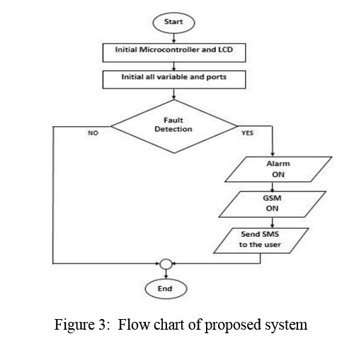

**Doors CLOSE**

Diagram 1.1 Flowchart of proposed system

**1.2 OBJECTIVES**

• To create a control system based on a microcontroller.

• Immediate defence against unauthorised physical intrusion

• To replace the traditional system.

• To give banks a user-friendly system so they can work effectively.

• To give bank customers peace of mind regarding their belongings.

**1.3 EXISTING SYSTEM**

People are constantly looking for secure locations to store their cash and other valuables. More responsible individuals believe that banks are the most dependable place to store their possessions. Bank security has been a critical element in ensuring that customers feel secure about their assets because valuables kept in bank vaults are typically the target of criminals. Banks have previously employed increased security, keypad cinches, burglar warnings, and biometric authentication. This system also puts up a trap for any potential offenders by automating bank security.

**CHAPTER 2**

**PROJECT DESIGN**

**2.1 VAULT DESIGN**

Bank vaults are built on custom orders. Typically, the design and construction of the vault begin with the new bank building. The design of the vault serves as the starting point for manufacturing, and rest of the bank is constructed before it. The client and the manufacturer of the vault consult to decide on details including the overall vault size, desired shape, controls, and door placement. The manufacturer sets up the machinery to create the vault lock panels and door after the customer approves the design. Typically, the consumer requests delivery and installation of the vault. In other words, the manufacturer of the creates the vault parts but also brings the components to the site and puts them together there.

There are many types of lock mechanisms in use:

* It's fairly usual to see combination locks, which function in a way similar to a padlock. This typically is a mechanical device, however there are goods with combined mechanical and electronic mechanisms, which makes it exceedingly challenging to use certain safe cracking techniques.
* A two piece key is sometimes used in unification with a combination lock in high-end vaults. The long stem and the short stamp that make up this key should be kept in separate safes and then combined to access the vault panel.
* Therefore a combination lock with dual control includes two dials that control the door's two locking mechanisms. They are typically set up so in order to unlock the door, both locks must be dialled open simultaneously. No one is given both combinations, thus two persons must work together to open the panel. Some panels may be set up so that either dial will open the door, compromising security for convenience.
* A timed lock is a clock that holds off unlocking the vault door for a certain number of hours. The "theft proof" lock system that was created by Sargent in the late nineteenth century is still in use today. Only a few businesses globally produce these locks. The locking system is delivered fully constructed to the producer of vaults.
* The locking system of the vault panel is likewise susceptible to many safe-cracking techniques. The door and panel's extreme strength and thickness could complicate things.

**2.2 METHODOLOGY**

In this project we are providing a more secure system. In we are using Arduino as the brain of  
the project. In the project we first made a +5v regulated power supply with 7805 voltage  
regulator then this supply is provided to different sections according to the circuit. Also we take out a 12v DC supply after rectification from a 1000uF capacitor for DC motor driving of the gate.

Then we make a Keypad for entering the password. We use 12 keys in the keypad for different functions. For the display of the password and virtual clock we use a 16x2 LCD which is attached to Port 1 in the project. Also, for the DC motor driving we first made an isolator circuit for the Arduino using P817 opto couplers. Then we make a H- Bridge Circuit for the forward and reverse direction of the motor We make a virtual clock on the LCD, when we need to enter a password, we press the hold key and enter the password according to divide by 2 logic. If the password is correct, it will open the door. If incorrect it displays the wrong password.

**2.1 BLOCK DIAGRAM**

**DC MOTOR**

**Micro switches for password**

**MOTOR DRIVE CIRCUIT**

ARDUINO

**+12v power**

**5v POWER SUPPLY**

**LCD 16*2 DISPLAY**

Diagram 2.1 Block Diagram

**2.2 CIRCUIT DIAGRAMS**

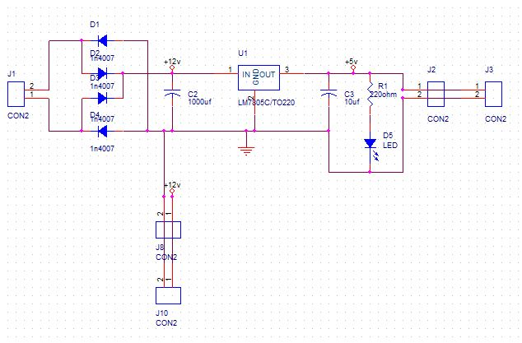

Diagram 2.2 Circuit Diagram

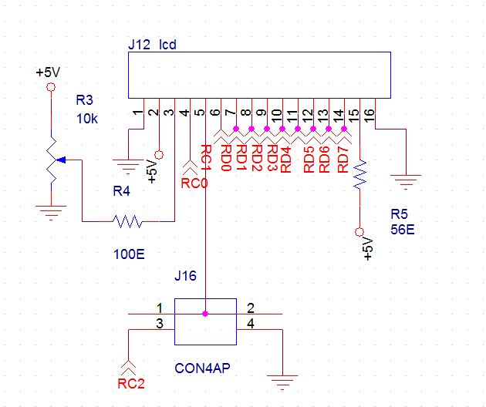

Diagram 2.3 LCD 16x2

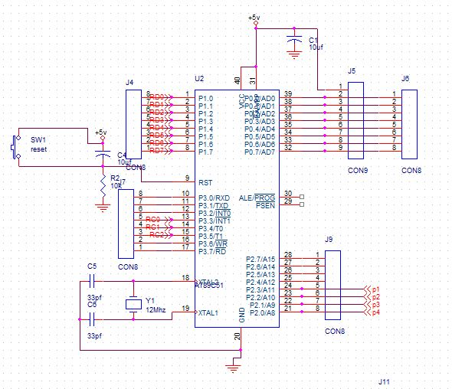

Diagram 2.4 Control Circuit

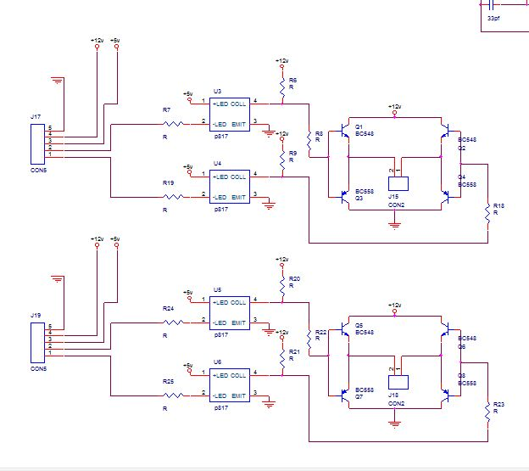

Diagram 2.5 Motor Driving Circuit

**2.4 H-Bridge**

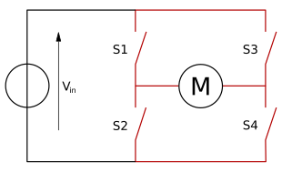An integrated circuit (IC) called a H-bridge can reverse the polarity of a voltage being applied to a load. H-bridges are used by the majority of DC-to-AC converters, the majority of motor controllers, the DC-to-DC push-pull converter, and more other types of electronics. In particular, a motor controller with two H-bridges enables a bipolar stepper motor to run.

Diagram 2.6 H Bridge

The control unit, display and keypad portion, as well as the DC motor unit, all receive power from the power section, which is a +5v dc supply. Using input from the keypad and an LCD display, the microcontroller unit controls the motors.

To operate the motors at high voltage, the H-bridge is used. For our virtual clock, which is synchronised with the LCD, we are employing a division by 2 logic in this project.

**Operation**

The H bridge's two fundamental states are:

The H bridge is used to switch the polarity of the motor, but it can also be used to STOP the motor, which causes it to sudden stop as a result of shorting, or to allow the motor to freely run because the motor is now unplugged from the circuit.

**2.5 EQUIPMENT AND APPARATUS REQUIRED**

**2.5.1 LCD**

Liquid crystal display device with the model number HD44780 LCD is the industry standard for interacting with embedded systems. There are several different screen sizes available for these displays, 16x2 and 20x4. Since HD44780 can only handle up to 80 characters, the most typical manufacturing arrangement requires two addressable HD44780 controllers with expansion shields.

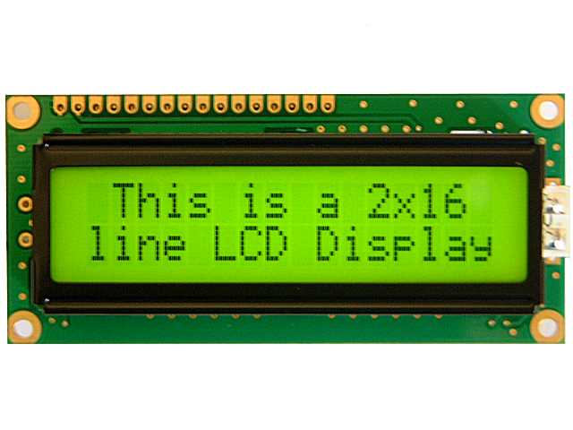

Fig 2.2 2X16 LCD Display

The text-only LCD panels are frequently found in storage devices, fax machines, laser printers, network equipment, and routers. Backlights for LCDs can be LED, fluorescent, or electroluminescent.

Standard LCDs have a 14-pin interface, whereas those with backlights have a 16-pin interface. The pinouts are as follows:

* Ground
* VCC
* Contrast adjustment
* Register Select (RS)
* Read/Write (R/W)
* Clock
* Bit 0 to 7
* Backlight Anode
* Backlight Cathode

A backlight pin may also exist, with the connection made up via the VCC pin. Pin 1 can come before the two backlight pins. Using a VDD 5V capable model, the backlight voltage is 4.2V.

Character LCDs have two operating modes: 4-bit and 8-bit. In 4-bit mode, pins 7-10 are left unoccupied, and the full byte is delivered to the screen by sending four bits (or nibbles) at a once using pins 11 through 14. 32 characters are found in 5x10 dot matrix and 208 character are found in a 5x8 dot matrix in the character generator ROM.

The Japanese version's 7-bit ASCII subset deviates from the norm by substituting left and right arrow symbols for the rub-out characters, as well as the Yen symbol for the backslash character. By employing specific commands, a small number of unique characters can be encoded into the gadget as bitmaps. Since they are kept in volatile memory, these characters must be written in the device each time it is turned on.

The liquid crystal display is a crucial component of embedded systems. It gives the user a great deal of versatility because he can display any data he needs. But many of them fail because of an improper approach to LCD interface. Many people view LCD interface as a challenging endeavour, but in my opinion, it's really rather simple; all you need is a rational approach. The article intended to assist who wants to understand how to interface LCD. When a system engineer wants to use LCD interface in practical projects, the copy and paste method might not work. You are aware of the space shuttle's boosters. The space shuttle could not launch into geosynchronous orbit without these booster rockets.

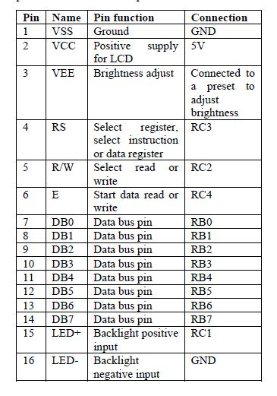

Table 2.1 LCD Pin Function

**2.5.2 DC MOTOR**

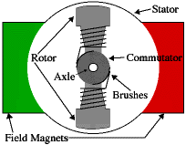An electrical motor that transforms direct current electrical energy into mechanical energy is known as a DC motor. We may infer that a DC motor is any electric motor that is driven by direct current, also known as DC. In the next sections, we'll learn how a DC motor is built and how it transforms the DC electrical energy it receives into mechanical energy.

Fig 2.3 Interior of DC Motor

An electric motor that transforms electrical energy into mechanical energy is a DC motor. It functions according to the Lorentz force principle, which stipulates that a current-carrying conductor will feel a force that is perpendicular to both the direction of the current and the direction of the magnetic field when it is put in a magnetic field. The conductor rotates as a result of this force, creating mechanical energy.

|  |  |  |  |
| --- | --- | --- | --- |
| The main components of a DC motor include:  1. Stator: The stator is the stationary part of the motor that contains the magnets or electromagnets that create the magnetic field. The stator can be made up of either permanent magnets or electromagnets.  Fig 2.4 DC Motor  2. Rotor: The rotor is the rotating part of the motor that contains the armature, which is a set Mabuchi motor pixof conductive coils wound around an iron core. When a current is passed through these coils, they produce a magnetic field that interacts with the magnetic field produced by the stator, causing the rotor to rotate.  3. Commutator: The commutator is a cylindrical component mounted on the rotor shaft that helps to reverse the direction of current flow in the armature coils as they rotate. This ensures that the magnetic field produced by the armature always interacts with the magnetic field produced by the stator in such a way as to keep the rotor rotating in one direction.  4. Brushes: The brushes are two or more conductive contacts that make contact with the commutator and allow current to flow into and out of the armature coils as they rotate.  5. Bearings: The bearings are components that support and guide the rotor shaft as it rotates within the stator. They are typically made up of metal balls or rollers that are held in place by a cage.  6. Housing: The housing is an outer casing that encloses all of the other components and provides protection from external elements. However, in practise, DC motors will almost always have three poles, which is a pretty typical amount. This prevents "dead spots" in the commutator, in particular.  A two pole motor commutator can briefly cut off the power supply when both brushes make simultaneous contact with both commutator contacts. The power supply would suffer, energy would be wasted, and motor parts would also be harmed.  Simply put, a DC motor is an apparatus that transforms direct current into mechanical energy. Today's factories place a high value on understanding the operating principle of DC motors in depth, and engineers should view this as equally crucial. We must first examine the constructional features of the dc motor in order to comprehend its functioning principle.  ImageIron core armatures are frequently used and have a number of benefits. First of all, the iron core offers the windings a sturdy, robust support, which is crucial for high-torque motors. The motor can be pushed harder than it otherwise might be because the core transmits heat away from the rotor windings. In comparison to other construction methods, iron core construction is also reasonably affordable. But there are also a number of drawbacks to iron core construction. Motor acceleration is constrained by the relatively high inertia of the iron armature. High winding inductances caused by this architecture further reduce brush and commutator life.  Fig 2.5 DC motor open along axis  A 'coreless' armature winding is a common alternative construction for tiny motors. The structural integrity of this design is reliant on the coil wire itself. The armature is hollow as a result, allowing the magnet to be installed inside the coil. Compared to iron-core motors of equivalent size, coreless DC motors have significantly reduced armature inductance, which prolongs the life of the brush and commutator.  Mechanical losses are those that the machine experiences as a result of mechanical friction. These losses happen as a result of windage losses and friction in the machine's spinning coil and other moving elements like bearings and brushes. Typically, these losses amount to about 15% of the whole load loss.  Due to the core's magnetization switching directions, losses happen in the armature winding. Armature's core performs a full revolution of magnetic reversal when exposed to a magnetic field. The magnetic lines are switched to overturn the magnetism inside the core, and section of the armature that is under the South pole will be under the North pole after completing half of the electrical revolution. The ongoing magnetic reversal process in the armature uses some energy, known as hysteresis loss. The quantity and quality of the iron affect the percentage of loss.    **2.5.3 PNP General Purpose Transistor**   |  |  |  | | --- | --- | --- | |  |  |  | |

Fig 2.6 pnp transistor

**2.5.5 Arduino Microcontroller**

Embedded system employs a combination of software & hardware to perform a specific function. It is a part of a larger system which may not be a computer, works in a reactive & time constrained environment.

An embedded system is any electronic device that uses a CPU chip but is not a general-purpose workstation, desktop, or laptop computer. These systems typically use microprocessors, microcontrollers, or both. They may also use specially built chips. Automobiles, trains, planes, spacecraft, machine tools, cameras, home and office appliances, cell phones, PDAs, and other handheld devices, as well as robotics and toys, all make use of them. There are countless applications for microprocessors, and every year billions of them are shipped.

In contrast to general-purpose computers, which constantly load their programmes into RAM, embedded systems permanently store their software in a read-only memory, such as a ROM or flash memory chip. Sometimes, single board and rack mounted general-purpose computers are called "embedded computers".

A microprocessor and a microcontroller are both integrated circuits that are used in electronic devices. However, there are some key differences between the two.

A microprocessor is a central processing unit (CPU) that is designed to process instructions. It is typically used in personal computers, servers, and other devices that require high processing power. Microprocessors are general-purpose chips that can be programmed to perform a wide range of tasks. They typically have a large number of pins and require external memory and input/output (I/O) devices to function.

On the other hand, a microcontroller is a complete computer system on a chip. It contains a CPU, memory, and I/O peripherals all on a single chip. Microcontrollers are typically used in embedded systems such as appliances, automobiles, and industrial control systems. They are designed for specific tasks and are often programmed to perform a single function. Microcontrollers have fewer pins than microprocessors and do not require external memory or I/O devices.

One of the main advantages of microcontrollers is their low cost and small size. Because they contain all the necessary components on a single chip, they are cheaper to manufacture than microprocessors. They also take up less space on a circuit board, making them ideal for small devices. Another advantage of microcontrollers is their low power consumption. Because they are designed for specific tasks, they can be optimized for low power consumption. This makes them ideal for battery-powered devices such as remote controls and sensors.

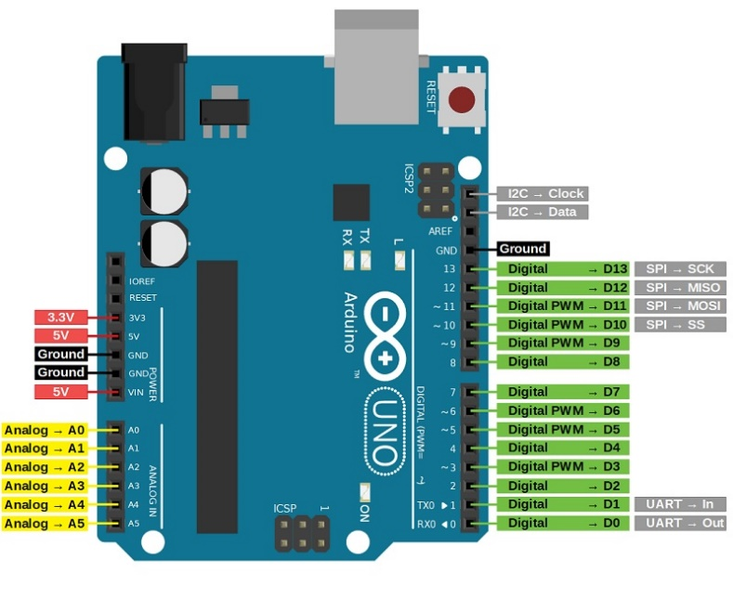**Arduino Architecture Overview**

Fig 2.7 Arduino Architecture

The Arduino family is one of the most used microcontrollers architecture around the world. There are hundreds of variations of Arduino-based microcontrollers available from several silicon manufacturers. The intention of the designers was to make it simple and affordable for experts, enthusiasts, and students to construct gadgets. The finest Arduino projects for beginners and amateurs include easy robots and motor detectors. Adafruit Industries predicted that more than 3 lakh Arduino boards would have been produced in 2011. However, users had 7 lakh boards in their possession in 2013. Numerous functioning devices, including those for communication or control, use Arduino technology.

**2.6 PRINTED CIRCUIT BOARD**

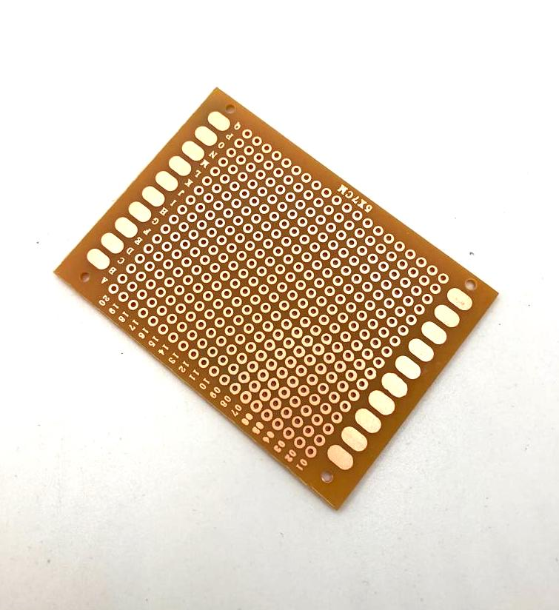A regulated connection between electrical components is made using a printed circuit board, often known as a printed wiring board or PWB. It has the appearance of a laminated sandwich structure with conductive and insulating layers, with each of the conductive layers having a pattern of traces, planes, and other features (like wires on a flat surface) etched from one or more copper sheet layers laminated onto and/or between sheet layers of a non-conductive substrate. Electrical components can be physically and electrically connected to conductive pads on the outer layers in the form intended to receive the component's terminals by soldering them to them. Vias are added during another manufacturing step.

Nearly all electrical products employ printed circuit boards. Point-to-point construction and wire wrapping were previously common PCB substitutes but are now rarely utilised. Circuit layout on PCBs necessitates more design work, but manufacturing and assembly may be automated. Software is available to automate most of the layout labour in electronic design. With PCBs, circuits may be produced in large quantities more quickly and affordably than with conventional wiring techniques since components are placed and connected all at once. Large quantities of PCBs may be manufactured simultaneously, and the layout only has to be done once. PCBs may also be produced manually, although the advantages are less.

*Fig 2.1 Printed Circuit Board*

**2.7 Hardware interfacings and programming**

Programming languages for microcontrollers fall into two categories:

* Low Level Language
* High Level Language

Advantages of C over Assembly language programming:

* Understanding the processor's instruction set is not necessary.
* The compiler is responsible for managing details like register allocation and memory and data addressing.
* Programs can be separated into distinct functions and receive a formal structure.
* Programming and program testing take much less time, which boosts efficiency.
* It is possible to use operational functions and keywords that are more analogous to human thought.
* Many industry-standard routines, including conversions of numbers, are present in the supplied and supported C libraries.
* Reusable code: Thanks to the practical modular programme construction methodologies, existing programme components can be more simply incorporated into new programmes.
* The ANSI-based C language is extremely portable. As needed, existing programmes can be quickly converted to work on different processors.

**CHAPTER 3 DEVELOPMENT AND IMPLEMENTATION**

**3.1 INTRODUCTION TO TOOL**

Software required: ARDUINO IDE

Two parts make up the Arduino platform:

1. The hardware, sometimes referred to as the microcontroller, is a real-world programmable circuit board. An 8-bit Atmel AVR microcontroller or a 32-bit Atmel ARM is the central component of this straightforward open-source hardware board. A variety of Arduino boards are available.
2. The Software: The computer's Integrated Development Environment (IDE), which is used to create and upload programming codes to the actual board. The microcontroller only runs a boot loader and a compiler for a common programming language.

An open-source integrated development environment (IDE) called Arduino IDE is used to programme Arduino boards. It is a cross-platform programme that functions on Windows, macOS, and Linux. For creating, building, and uploading code to Arduino boards, the IDE offers a user-friendly interface. Simplified C++ is the programming language used by the Arduino IDE, which is based on the Processing programming language. Code editing tools like syntax highlighting, auto-completion, and error highlighting are included. A serial monitor is also included in the IDE for testing and debugging programmes. The Arduino IDE's library manager, which enables users to quickly download and install libraries for their projects, is one of its standout features. For typical activities like operating LEDs, reading sensors, and interacting with other devices, these libraries offer prewritten code. The Arduino IDE's capability to handle several Arduino boards is another crucial feature. The compiler and uploader parameters are then adjusted as necessary by the IDE once users choose the board they are using from a drop-down menu. The Arduino IDE enables third-party plugins and extensions in addition to its main functionality. These can include new programming languages or extra features like support for new boards.

Arduino is an open-source electronics platform based on easy-to-use hardware and software. It consists of a programmable circuit board, also known as a microcontroller, and a software development environment used to write and upload code to the board. Arduino boards are designed to be accessible to artists, designers, hobbyists, and anyone interested in creating interactive objects or environments. The Arduino board can be connected to various sensors, switches, LEDs, motors, and other electronic components to create projects that interact with the physical world. The software development environment, called the Arduino IDE (Integrated Development Environment), is based on the Processing programming language and allows users to write code in a simplified version of C++. Arduino has become popular among makers and DIY enthusiasts due to its ease of use and versatility. It has been used in a wide range of projects, including robotics, home automation, wearable technology, and more.

One of the key features of Arduino is its open-source nature. This means that the hardware design files and software code are freely available for anyone to use, modify, and distribute. This has led to a large community of users who share their projects and collaborate on new ideas. In addition, a boot loader that is pre-programmed into an Arduino's microcontroller makes uploading programmes to the on-chip flash memory simpler than it would be for other devices that normally require an external programmer.

Both- physical programmable circuit board and programming software, or IDE (Integrated Development Environment), that can be run on a PC are components of Arduino. The IDE is used to create and send PC code to the circuit board. The Arduino Software (IDE), based on Processing, and the Arduino Programming Language (based on Wiring), can be used to accomplish this. The Arduino, in contrast to previous programmable circuit boards, allows one to upload code to the circuit board effectively using a USB link without the need for additional hardware (referred to as a software engineer). Additionally, the Arduino IDE uses a modified version of C++ that makes learning to programme easier. In a nutshell, Arduino packages the micro-controller's features into a more user-friendly form. One of the most popular boards in the Arduino family and a fantastic choice for beginners is the Uno.

**Common Components of Arduino Boards**

There are diﬀerent types of Arduino boards for diﬀerent purposes. But all the boards have the majority of following components in common.

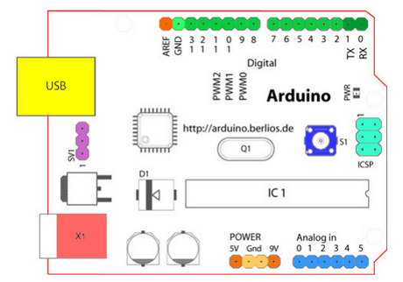

*Fig 3.1: Common Components of Arduino Boards*

Arduino boards are open-source microcontroller boards that are designed to make electronics more accessible to everyone, from beginners to experts. They are widely used in various projects such as robotics, home automation, and IoT devices. The common components of an Arduino board include:

1. Microcontroller: This is the brain of the Arduino board, which controls all the inputs and outputs. The most common microcontrollers used in Arduino boards are from the Atmel AVR family, such as ATmega328P, ATmega2560, and ATmega32U4.
2. Crystal oscillator: This component provides a clock signal to the microcontroller, which is necessary for accurate timing and synchronization of operations.
3. Voltage regulator: Arduino boards typically operate at 5V or 3.3V, but they can accept a wide range of input voltages. The voltage regulator ensures that the voltage supplied to the microcontroller and other components is stable and within the specified range.
4. USB interface: This allows the Arduino board to communicate with a computer or other devices via USB cable. It is used for programming the board and transferring data between the board and external devices.
5. Power jack: This is an alternative power supply input for the Arduino board, which can be used instead of USB power.
6. Digital I/O pins: These pins can be configured as either input or output, allowing the microcontroller to communicate with external devices such as sensors, LEDs, motors, and other electronic components.
7. Analog input pins: These pins allow the microcontroller to read analog signals from sensors or other sources.
8. Reset button: This button resets the microcontroller
9. LEDs: Most Arduino boards have built-in LEDs that indicate power status, communication status, or other functions.
10. Headers: These are connectors that allow external devices to be connected to the Arduino board, such as shields, sensors, or other expansion boards.

**3.2 WORKING**

A security system for an ATM operates differently from conventional security systems. In the project, we first constructed a +5v controlled power supply using a 7805 voltage regulator, and then we provided this supply to other circuit components as needed. Additionally, we remove a 12v DC supply from a 1000uF capacitor after rectification for the DC motor operating of the gate.

After that, a keypad is created for entering passwords. The keypad has 12 keys that we use for various purposes. In the project, we utilise a 16x2 LCD that is connected to Port 1 for the display of the password and virtual clock. Additionally, we first created an Arduino isolator circuit using P817 opto couplers for the DC motor driving. After that, an H-Bridge Circuit is created to control the motor's forward and reverse motion.

When entering a password, we create a virtual clock on the LCD, press the hold key, and then enter the password using the division by 2 logic. The right password will unlock the door. If incorrect, the incorrect password is displayed. The mathematical equation is essential to the endeavour. Construct a code to compare the entered value with a divide-by-2 logic, and implement a virtual clock.

**CHAPTER 4**

**CONCLUSION AND FUTURE SCOPE**

**4.1 CONCLUSION**

This project is aimed at amplifying the bank vault security system. One of the key features of the Valt Security System is its ease of use. The system can be easily installed by anyone with basic DIY skills. The Valt Security System is an excellent choice for anyone looking for a reliable and easy-to-use security system for their home or business. Its user-friendly interface makes it security systems on the market today.

**4.2 FUTURE SCOPE**

The development of better concrete material resulted in a fast revolution in vault technology in the 1980s to 1990s. While bank break-ins are not the major issue, they were from the late 19th century to the 1930s, vault manufacturers still change their products to combat new break in techniques. Even nuclear blasts may be absorbed by vaults.

**REFERENCES**

1. 8-bit AVR Microcontroller, ATMEL, 2011.
2. C. Reas, B. Fry, and J. Maeda, Processing: A Programming Handbook for Visual Designers and Artists. The MIT Press, 2007.
3. Jayalakshmi, K., Ramanarayanan, V., “Real-time simulation of electrical machines on FPGA platform”, Power Electronics, 2006. IICPE 2006. India International Conference